**How to use QLabel**

**To place an image into a QLabel object**

1. Drop a QLabel object from tool box onto the form.
2. Select object and browse to the pixmap property in the property editor window.
3. Click the value box of the pixmap property and click on ‘choose file’. From the file dialog, select the required image file. The images is now displayed in the label widget.

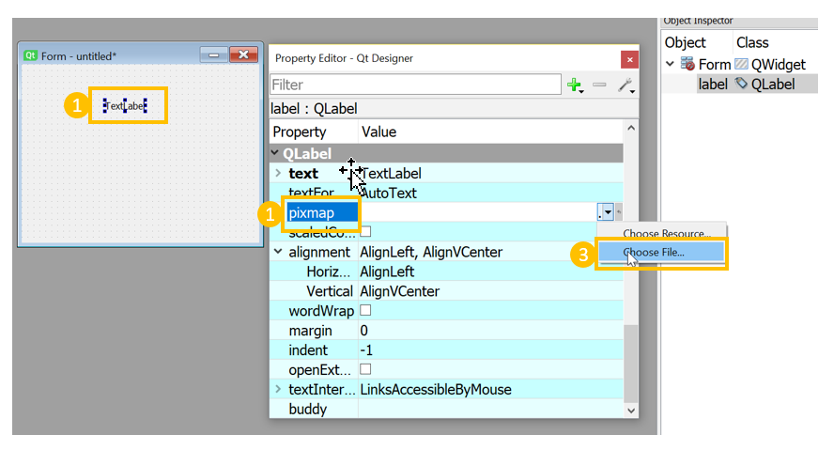

**To add a hyperlink into a QLabel object**

1. Drop a QLabel object from tool box onto the form.
2. Select the QLabel object and scroll to the text property.
3. Click the Edit text button to the right of the text label box.
4. To make this a hyperlink, click the Source tab below and add the HTML attribute tag with the required text. In this example, a link to the Internshala trainings website is added.

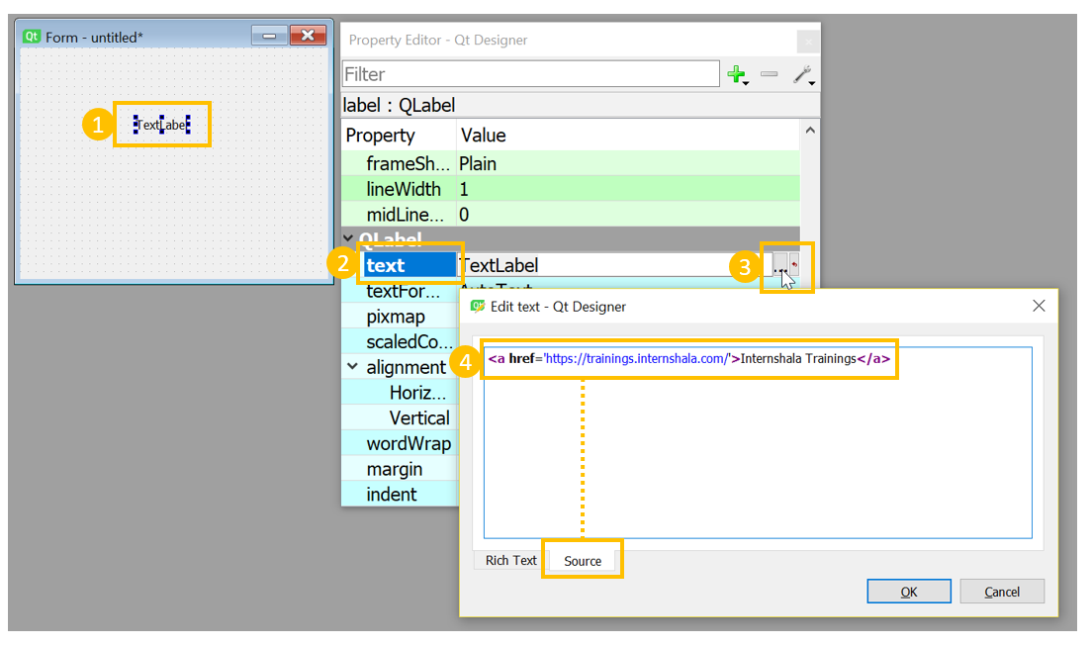

1. To open the hyperlink in a new window, scroll to the OpenExternalLinks property.
2. Select the box to set it to true. 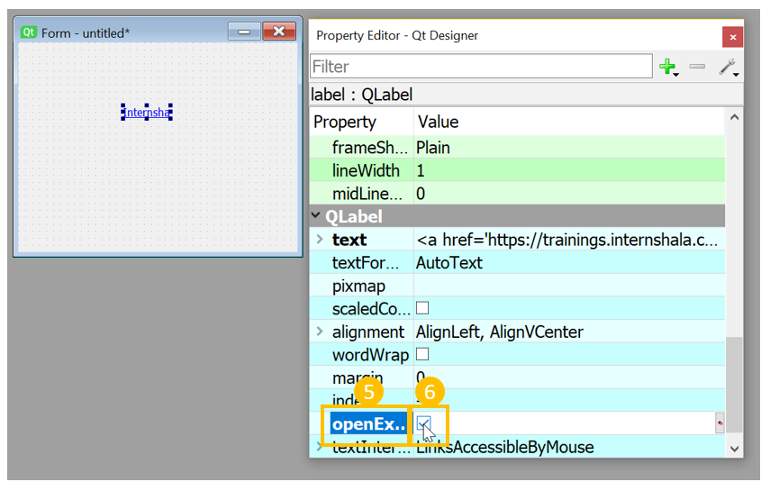

**To align the QLabel object with respect to the window**

1. Select the QLabel object and scroll to the alignment property node.
2. Set the horizontal property to the required alignment, for example AlignHCenter.
3. Set vertical property to the required alignment, for example AlignVCenter.